1. Tables - with simple layout

Pink Frag Event Organization is one of the Best Event Management Companies who organize and manage events that leave a lasting impression and project its perfection. They provide the leading event management services for birthday, wedding, corporate events and business conference. To make their business presence online, they have planned to create a webpage for their company. Zohon, the Manager of the company assigned Kiara to the company's website development. She planned to include many pictures related to the events on the website and created an index page with multiple images.

Upon reviewing Kiara's home page, Zohon suggested her to include the information regarding the company like its logo and the details of the event, etc,. Help her to create the index page of the website using html, which contains the logo of the company along with the details of the events. The web page should be designed using table and colspan attribute.

Hints :

Attribute colspan

An HTML table with a table cell that spans two columns. The colspan attribute defines the number of columns a cell should span.

Tag <img>

The <img> tag defines an image in an HTML page.

Syntax :

<img src = "xxx.png" >

Content :

h1 - Pink Frag Event Management

Simple Layout Format

First Row

    td - colspan1 - left logo 'eventLogo1.png' with id 'eventLogo1'.  
    td - colspan4 - Ping Frag Event Management   
    td - colspan1 - right logo 'eventLogo2.png' with id 'eventLogo2'.

Second Row

     td - colspan2 -  Event management is the application of project management to the creation and development of large scale events such as festivals, conferences, ceremonies, weddings, formal parties, concerts, or conventions. It involves studying the brand, identifying its target audience, and coordinating the technical aspects before actually launching the event.  
     td - colspan2 - The process of planning and coordinating the event is usually referred to as event planning and which can include budgeting, scheduling, site selection, acquiring necessary permits, coordinating transportation and parking, arranging for speakers or entertainers, arranging decor, event security, catering, coordinating with third party vendors, and emergency plans.  
     td - colspan2 - Each event is different in its nature, so process of planning & execution of each event differs on the basis of type of event. The events industry now includes events of all sizes from the Olympics down to business breakfast meetings. Many industries, charitable organizations, and interest groups hold events in order to market themselves or celebrate an achievement.

Third Row

    td - colspan3   
         title - Wedding Planner  
         A wedding planner is a professional who assists with the design, planning and management of a client's wedding. Weddings are significant events in people's lives and as such, couples are often willing to spend a considerable amount of money to ensure that their weddings are well-organized.  
     td - colspan3  
         title - Corporate Event  
         A corporate event can be defined as a gathering that is sponsored by a business for its employees, business partners, clients and/or prospective clients. These events can be for larger audiences such as conventions or smaller events like conferences, meetings or holiday parties.

Constraints :  
'table' tag should be used to design the web page.  
table id should be 'eventTable'.  
The first row must have 3 td's with colspan attribute specified in the screenshot.  
The second row must have 3 td's with colspan attribute specified in the screenshot.  
The third row must have 2 td's with colspan attribute specified in the screenshot.  
  
Note :  
Web page should be displayed as shown in the screenshot.  
Kindly refer the content which is given as a part of the description  
  
Sample Screenshot 1 :  
  
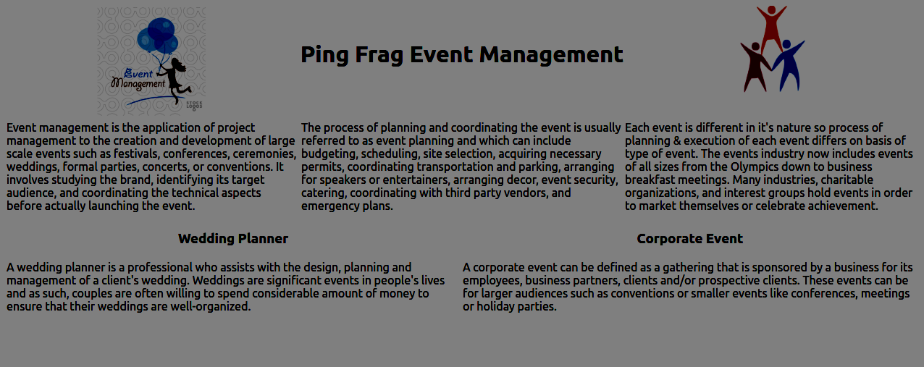

2.Tables - rowspan

Pink Frag Event Organization is a popular event managing company in Mumbai has successfully organized many events in the city. Manohar, a web designer and a key person of that company has created the web site for their company. He has been assigned to modify and add new functionality in the web page to create an event schedule.  
  
The web page created by Manohar is reviewed by his superior and he felt that the page looked a little bit clumsy and unorganized. He suggested Manohar to rework on the row spacings of the event schedule table. Hence help him to do the specified task. Write a program to create an html page with the usage of rowspan attribute in the table.

Hints :

Attribute rowspan

The rowspan attribute defines the number of rows a cell should span.

Syntax :

<td rowspan="2"></td>

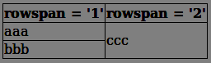

Content :

h1 tag - Pink Frag Event Organizer

|  |  |  |  |
| --- | --- | --- | --- |
| **Name** | **Venue** | **Start Time** | **End Time** |
| Wedding Planning | Sri Plus Thirumana Mahal | 4.5.2018 9.00AM | 4.5.2018 12.00PM |
| RVS Hall, 2nd Floor | 6.9.2018 9.30AM | 6.9.2018 12.30PM |
| Award Ceremonies | Vivekanandha Auditorium | 6.1.2018 10.00AM | 6.1.2018 1.00PM |
| Paga Towers | 11.3.2018 9:30 AM | 11.3.2018 12:30 AM |
| Promotion Party | Bath Record Office | 1.3.2018 9:30 AM | 1.3.2018 5:30 PM |
| RVM Hall | 21.01.2018 10:00 AM | 21.01.2018 1:00 PM |
| Incentive Party | Tower, Hall No 2 | 20.2.2018 4.30 PM | 20.2.2018 5:30 PM |
| Hindustan Auditorium | 15.2.2018 4.30 PM | 15.2.2018 8.30 PM |
| Product Launches | Tower, Hall No 4 | 25.1.2018 2.30 PM | 25.1.2018 8.30 PM |
| Hindustan Auditorium | 15.4.2018 10.30 AM | 15.4.2018 2.30 PM |

Constraints :  
'table' tag should be used to design the html page.  
Create rows by using 'tr' tag.  
The first row represents the header in the table. It should be inside the 'th' tag.  
All the event specifications should be inside the'td' tag of the corresponding row.  
Use rowspan attribute to merge two rows in the table.  
  
Note :  
Web page should be displayed as shown in the screenshot.  
Kindly refer the content which is given as a part of the description.  
  
Sample Screenshot 1 :  
  
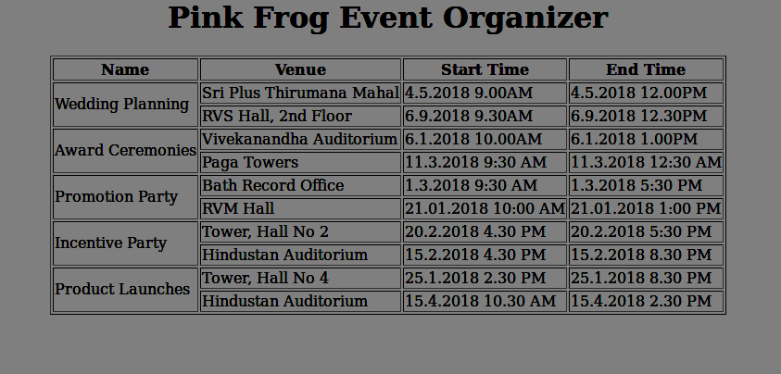  
  
Sample Screenshot 2 :  
  
